% Roll No: 207

% Batch: C3

% Date: 13-04-2023

% Name: Mohanish Khambadkar

% Assignment 5

function [y] = trap(x)

%main function

y=0.2+25\*x-200\*x^2+675\*x^3-900\*x^4+400\*x^5

end

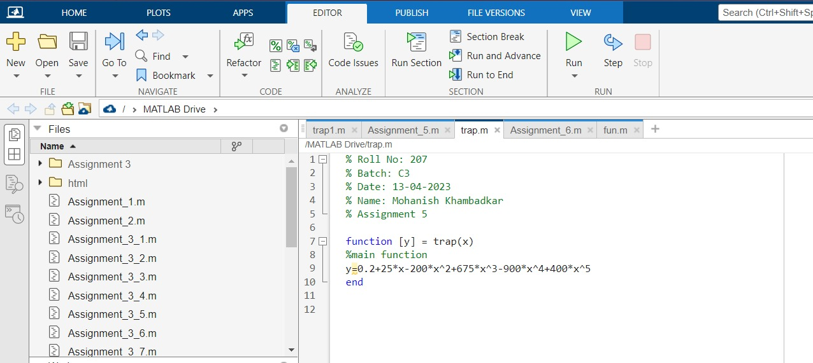

function [y1] = trap1(x)

%Integrated function

y1=0.2\*x+(25\*x^2)/2-(200\*x^3)/3+(675\*x^4)/4-(900\*x^5)/5+(400\*x^6)/6

end

